ESP Lab1: Prep Sheet

Signal Modulation by Decimation and Interpolation
Group / Team | Team member 1: | Pham, Tuong Minh
ESPL05 / F (please change) | Team member 2:
ESPL05 / F (please change) | Team member 3:
Table 1: Different configurations to be used by different lab groups
Lab group as chosen in myHAW | Down- / Upsampling factor | Chirp, from … to [kHz], length [s] |  | Bat sound $f_{bat}$ | Sampling frequency ADC, DAC $f_{s}$ [kHz] | Polyphases $x_{λ}$ output at DAC CH0 / CH1
ESPL/01 | M=L=3 | 18 … 21 kHz | 2.5 s | 18 kHz | 50 kHz, 50 kHz | $$λ=0 / λ=2$$
ESPL/02 | M=L=4 | 14 … 17 kHz | 3.0 s | 15 kHz | 50 kHz, 50 kHz | $$λ=0 / λ=3$$
ESPL/03 | M=L=5 | 21 … 24 kHz | 2.0 s | 17 kHz | 50 kHz, 50 kHz | $$λ=0 / λ=4$$
ESPL/04 | M=L=5 | 18 … 21 kHz | 3.0 s | 16 kHz | 50 kHz, 50 kHz | $$λ=0 / λ=3$$

Preparation
Use of generative AI
Tool: Claude (Anthropic), October 2026. The lab instructions and the Moodle files (Tutorial2_FIR_filter.m, write_coeff.m, dec_int_standalone.c, FIR filter files) were provided as context.
Essential prompts (translated from German, condensed):
1. "Write a prompt that I can use to work on the preparation tasks of ESP Lab 1."
2. "Lab group ESPL/01: M = L = 3, chirp 18–21 kHz, 2.5 s, f_bat = 18 kHz, f_s = 50 kHz, polyphases λ = 0 / λ = 2. Create a commented MATLAB script for sections 3.1–3.5 with all required plots, using firpmord/firpm and write_coeff as in the tutorial script. Explain for each section why the result is correct, using concrete frequencies. Extend dec_int_standalone.c to M = L = 3 and explain why g_PolyWUpdate is necessary. Explain every non-trivial step so that I can explain the code in the lab."
3. "Why do I look at 60 samples in the stem plot of section 3.1?"
Verification: The MATLAB script was run and the filter order, coefficient values and stop-band attenuation were checked in the command window. The C code was compiled and executed on onecompiler.com and the output was checked for the expected polyphase pattern.

Creating a Chirp Signal
Add your results, including Matlab code and figures, to the preparation sheet. Explain why you think the result is correct.
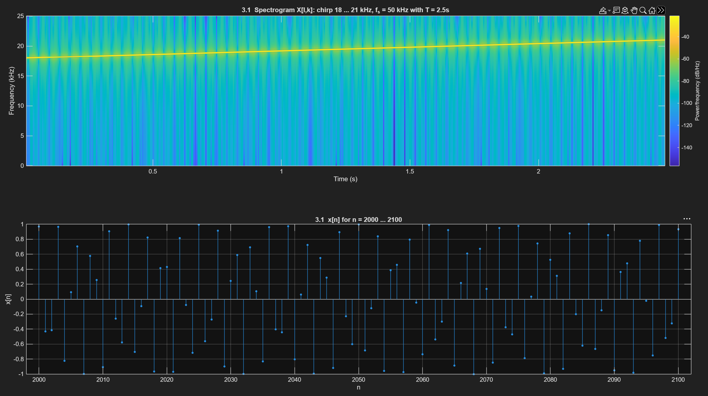
The spectrogram X[l,k] shows a single straight line risiDownsampling and Polyphase Representation
Add your results, including Matlab code and figures, to the preparation sheet. Explain why you think the result is correct.

Upsampling without Interpolation Filter
Add your results, including Matlab code and figures, to the preparation sheet. Explain the shape of the spectrogram and provide reasons based on specific frequencies. Assume that a bat sound of $f_{bat}$ (as given in Table 1 for your ESPL group) is fed into the system's ADC. Is it reproduced at the DAC output? If so, at what frequency / frequencies?

Applying an Interpolation Filter
Add your results, including Matlab code and figures, to the preparation sheet. Compare the results from 3.3 and 3.4 and explain them.

Export Filter Coefficients to C
Generate the header file for the filter coefficients of your interpolation filter and bring the file with you to the lab session. How many coefficients does your FIR filter have? Which is the largest and which the smallest value? Do these values fit into 16-bit format? Explain.

C Program with Interrupt Handlers
Extend the code for $M$ and $L$ values given in Table 1 for your ESPL group. The polyphases $x_{λ}\left[m\right]$ specified in Table 1 should be fed to the respective DAC outputs. Why is g_PolyWUpdate necessary? Add your C code to the preparation sheet.

The preparation is complete. Congratulations! Please submit the preparation sheet in Moodle before the lab session.

